Day-5 Assignment
Q1. On your Windows laptop or PC, open 'System Information' and take a screenshot showing your OS version, processor, and RAM details.
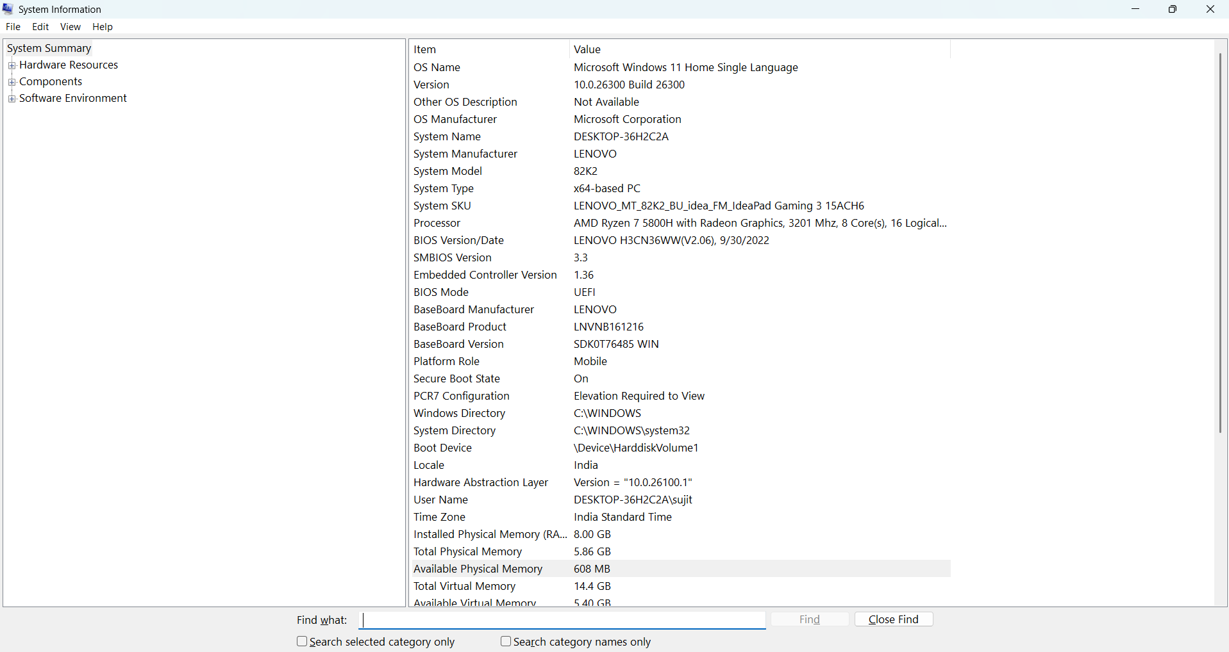
Ans.

Q2. Download any official Linux distribution ISO (like Ubuntu or Fedora), and use Rufus or BalenaEtcher to create a bootable USB drive for installation(Hint: If you don't have a spare USB, use a virtual machine tool like VirtualBox to mount the ISO and start the installation process virtually.)
Ans.
Step 1: Download the Ubuntu ISO
Open the official Ubuntu download page:
Download Ubuntu Desktop ISO
Download the Intel/AMD 64-bit ISO for a typical Windows PC. Save the file in your Downloads folder.
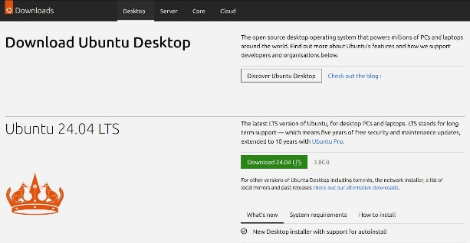
Step 2: Download Rufus
Open the official Rufus website:
Download Rufus
Download and open the Windows version. Rufus creates bootable USB drives from ISO files.
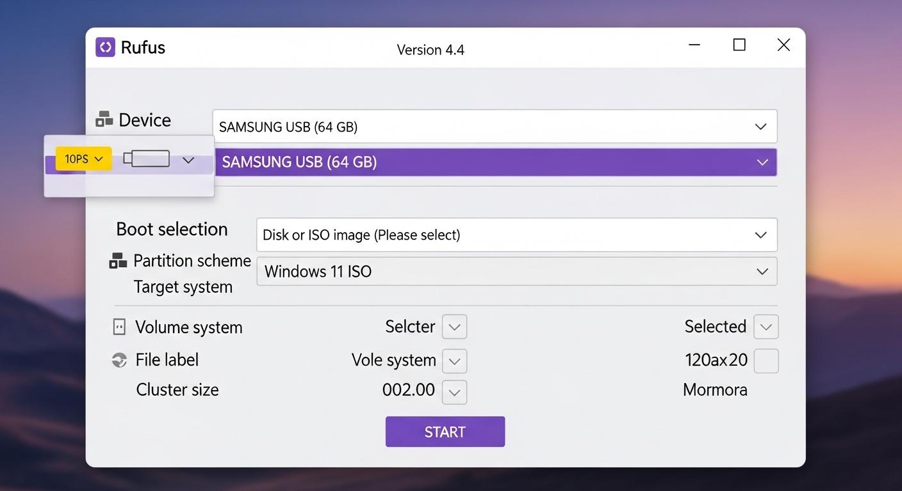
Step 3: Insert a USB drive
Connect an empty USB flash drive, preferably 16 GB or larger, to your computer.
Warning: Creating the bootable drive will erase the data on the selected USB. Back up your files first.
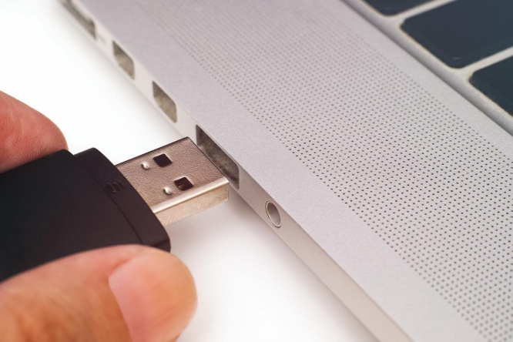
Step 4: Configure Rufus
In the Rufus window:
- Device: Select your USB drive.
- Boot selection: Choose Disk or ISO image.
- Click SELECT and choose the downloaded Ubuntu .iso file.
- Partition scheme: Choose GPT for a typical modern UEFI PC, if appropriate for your system.
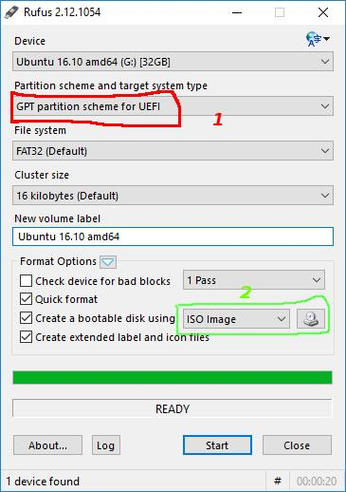
- Leave other settings at their recommended defaults.

Step 5: Create the bootable drive
Click START. If Rufus asks how to write the image, choose ISO Image mode when offered.
Confirm the warning about erasing the USB, then wait until Rufus displays READY.
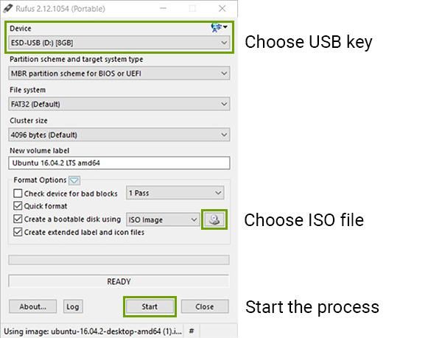
Step 6: Verify the USB (optional)
Restart the PC and open its boot menu using the manufacturer's key, often F12, Esc, or F9. Select the USB drive.
Choose Try Ubuntu to test Linux without installing it on your computer, if that option appears. Exit and remove the USB when finished.
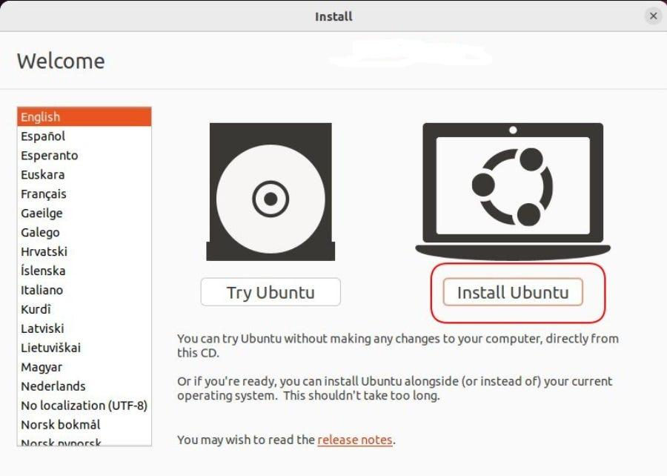

Q3. On a macOS device (or using a macOS virtual machine), open 'System Preferences' and change the desktop wallpaper, then adjust the system language to Hindi or Gujarati.(Hint: Find 'Language & Region' in System Preferences to add or change languages.)
Ans.
Practical: Change Desktop Wallpaper and System Language on macOS
Objective: Change the desktop wallpaper and set the system language to Hindi or Gujarati on a Mac.
The steps depend on your macOS version. Newer versions use System Settings, while older versions use System Preferences.
Part 1: Change the desktop wallpaper
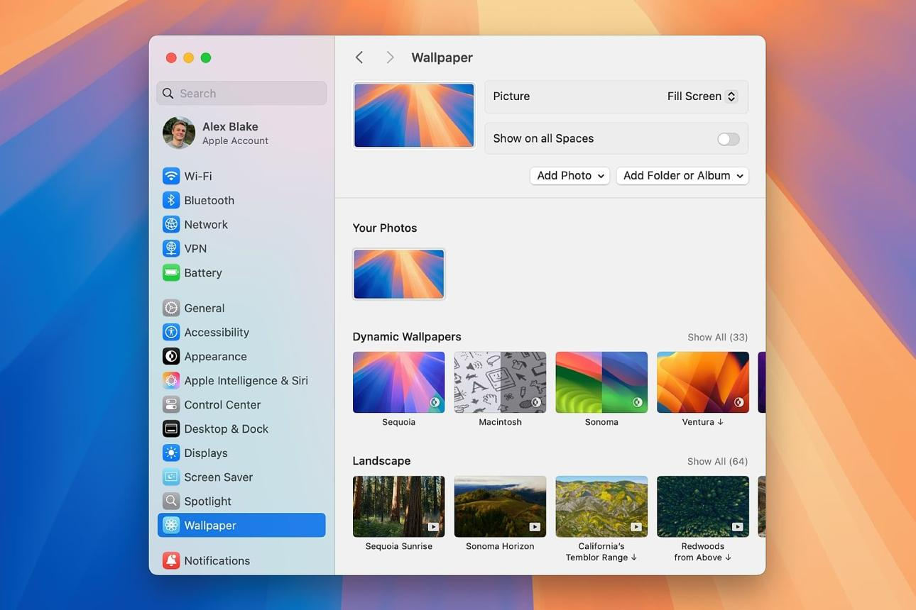
- Click the Apple menu () in the top-left corner.
- Select System Settings.
- Click Wallpaper in the sidebar.
- Choose any built-in wallpaper, such as a landscape, nature image, or abstract design.
- Wait for the desktop background to change.
For older macOS versions, open Apple menu → System Preferences → Desktop & Screen Saver → Desktop and select a wallpaper.
Part 2: Change the system language to Hindi or Gujarati
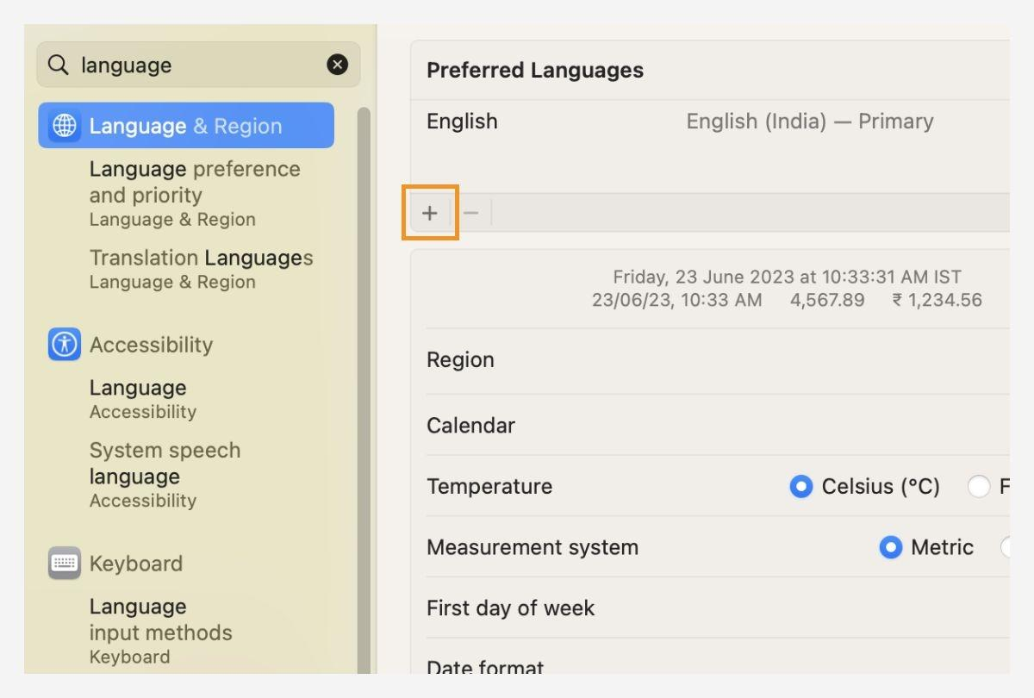
- Click the Apple menu () → System Settings.
- Select General → Language & Region.
- Under Preferred Languages, click the + (Add) button.
- Search for and select Hindi or Gujarati.
- Click Add.
- Drag your chosen language to the top of the Preferred Languages list to make it the primary language.
- If macOS asks you to restart, choose Restart Now.
Note: Languages listed below the separator in the language-selection window may not be fully supported for the macOS interface. If Gujarati is listed there, choose Hindi if it is available as a fully supported system language.

Q4. Install a fresh copy of Ubuntu Linux (real or virtual machine) and create a new user account named 'gamer'. After installation, enable automatic login for this user and take a screenshot of the login screen showing the username.
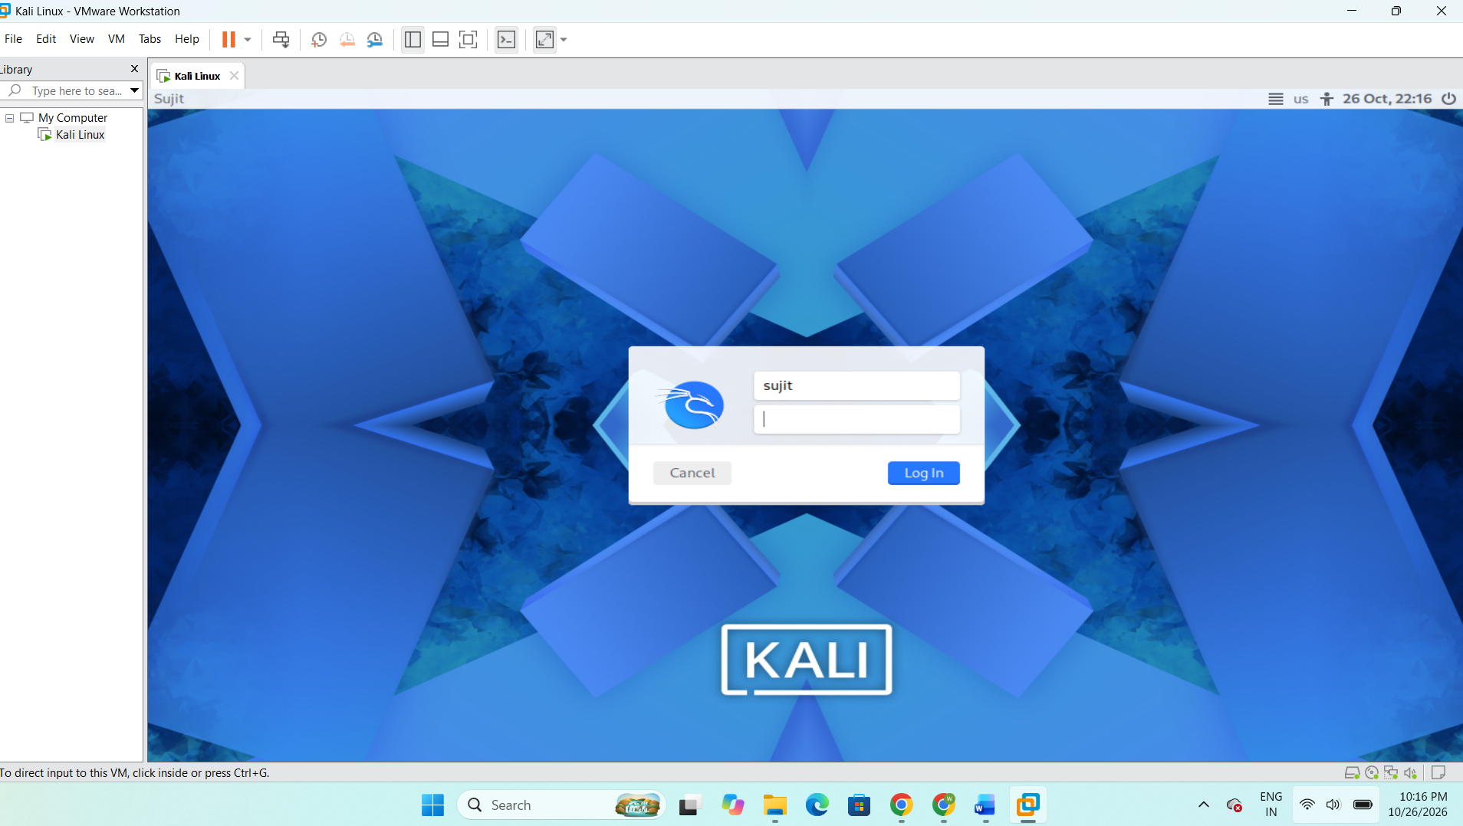
Ans.

Q5. Use ChatGPT to generate a step-by-step guide for installing Windows 10 on a laptop, including partitioning tips and post-installation settings for privacy and updates. Follow the guide and note any steps that were unclear or missing.
Ans.
Part 1: Prepare for installation
Before starting, collect the following:
Requirement | Purpose
Windows 10 installation media | Contains the Windows setup files
USB flash drive of at least 8 GB | Creates a bootable installer
Reliable internet connection | Downloads the installation files and drivers
Laptop charger | Prevents shutdown during installation
Windows product key or digital licence | Activates the correct Windows edition
Backup of important files | Protects documents, photos, and other data
Before proceeding: Back up all important files, save your BitLocker recovery key if encryption is enabled, and disconnect external drives that should not be changed.
Part 2: Download Windows 10
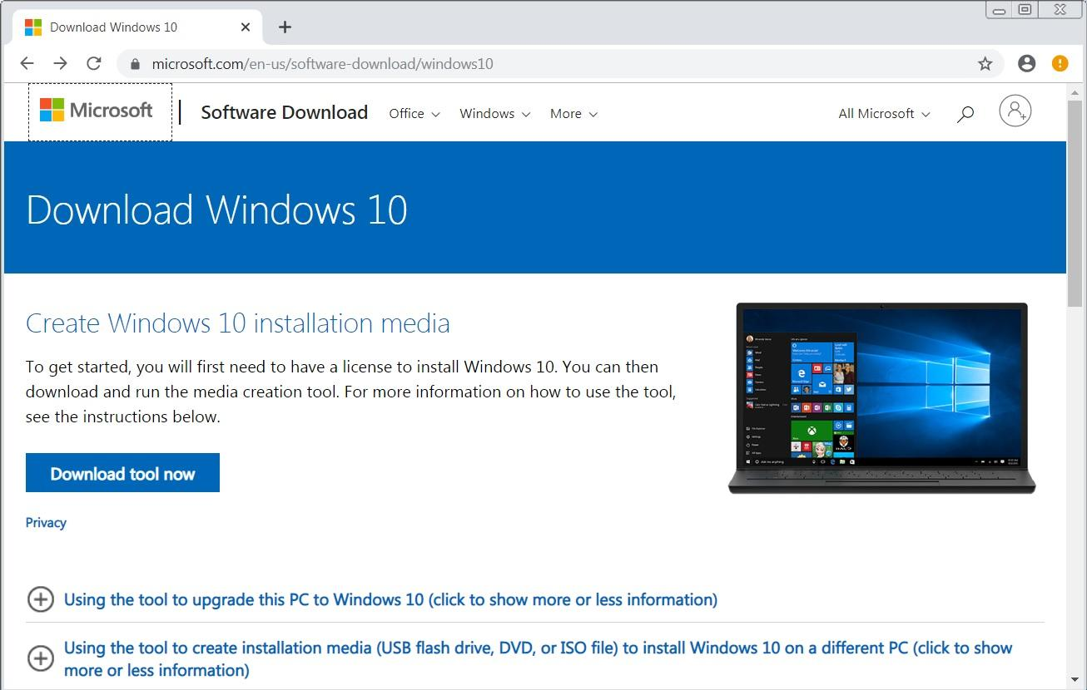
Step 1: Open the official download page
Visit the official Microsoft Windows 10 download page.
Find the section for creating Windows 10 installation media.
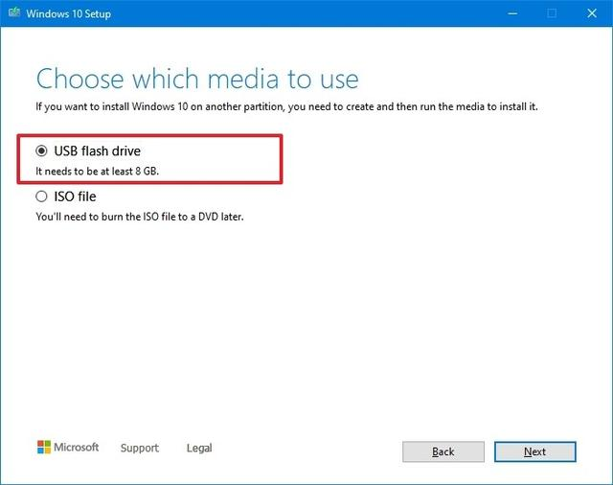
Step 2: Download the Media Creation Tool
Select Download Now, if the option is available, and open the downloaded tool.
Accept the licence terms, then select Create installation media for another PC if that option appears.
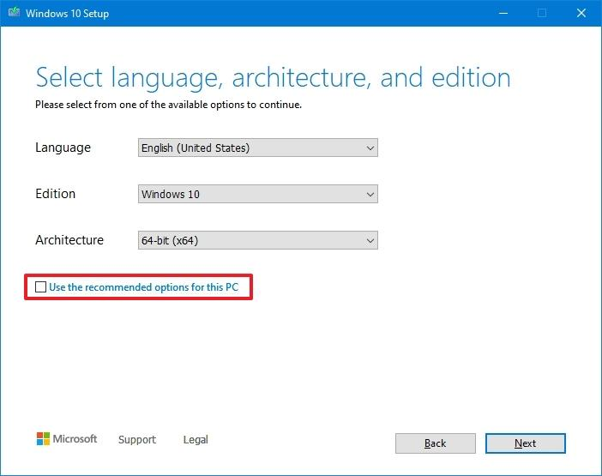
Step 3: Create the installation USB
Select the appropriate language and architecture, normally 64-bit for a modern laptop. Choose USB flash drive, select the correct USB device, and let the tool create the installer.
Warning: This process erases the selected USB drive.
Part 3: Start Windows Setup
- Shut down the target laptop and insert the bootable USB drive.
- Switch on the laptop and repeatedly press its boot-menu key. Common examples are F12, Esc, or F9, but the correct key depends on the manufacturer.
- Select the USB drive, preferably its UEFI entry if the laptop uses UEFI.
- When Windows Setup opens, select the language, time format, and keyboard layout.
- Click Next → Install now.
- Enter your Windows product key when requested. If you have a valid digital licence for the same Windows edition, the option I don't have a product key may be appropriate; activation can be checked after installation.
- Select the Windows edition that matches your licence, accept the licence terms, and continue.
- Choose Custom: Install Windows only (advanced) for a clean installation.

Part 4: Disk partitioning tips
This is the most important step to understand before installing Windows.
When the installer displays Where do you want to install Windows?, you will see the available disks and partitions.
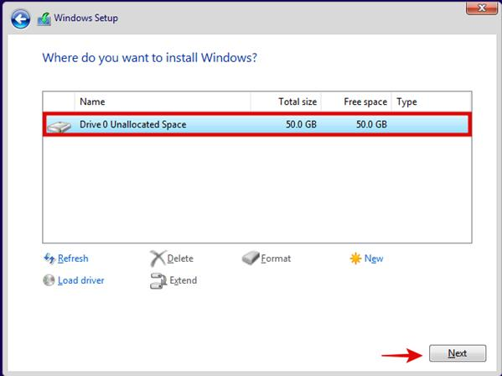
Partition option | Meaning
EFI/System partition | Contains files required to start Windows on a UEFI system
Primary partition | Usually contains Windows or user data
Recovery partition | Holds tools used to recover or repair Windows
Unallocated space | Disk space that has not been assigned to a partition
For a clean installation on a dedicated target disk:
- Identify the correct disk using its size and other available information.
- Confirm that all files on that disk have been backed up.
- Only if you intend to erase the entire target disk, delete its partitions one at a time.
- Once the target disk shows unallocated space, select that space and click Next.
- Allow Windows Setup to create the required partitions automatically.
Do not delete partitions if you are uncertain which disk they belong to. If the computer contains more than one drive, leave any drive containing files you need untouched. For dual-boot installations, do not use the clean-install deletion procedure; get specific guidance for the existing partition layout first.
Part 5: Complete Windows installation
- Wait for Windows to copy files and install the operating system.
- Allow the computer to restart as required.
- If the installer starts again from the USB after a restart, remove the USB or choose the internal drive from the boot menu.
- Follow the first-start setup screens.
- Select your region, keyboard layout, network, and account options.
- Review the privacy choices shown during setup.
- Once the desktop appears, verify that Windows starts normally.
Part 6: Configure privacy settings
Open Start → Settings → Privacy in Windows 10.
1. General privacy settings
Open Privacy → General. Turn off Let apps use advertising ID to make ads more interesting to you based on your app activity if you do not want this advertising identifier used.
2. Diagnostics & feedback
Open Privacy → Diagnostics & feedback. Review the diagnostic-data and tailored-experience settings, and disable optional data-sharing features where available and appropriate. Some diagnostic data is required by Windows.
3. Location
Open Privacy → Location. Allow location access only where it is needed, such as a mapping application.
4. Camera and microphone
Open Privacy → Camera and Privacy → Microphone. Review which applications can access these devices and disable access for apps that do not need it.
These options help control advertising identifiers, diagnostic information, and application permissions. Their exact availability depends on the Windows version and device configuration.

Part 7: Check Windows updates and drivers
- Open Start → Settings → Update & Security → Windows Update.
- Select Check for updates.
- Install any updates offered for your installation and restart if prompted.
- Open Device Manager and check for devices with yellow warning symbols.
- Download any missing chipset, Wi-Fi, graphics, audio, or touchpad drivers from your laptop manufacturer's official support website.
- Open Settings → Update & Security → Activation and confirm the activation status.
Remember that ordinary Windows 10 installations no longer receive free security updates after October 14, 2025. Checking Windows Update does not by itself guarantee that the system is protected by current security fixes.
Part 8: Record unclear or missing steps
I have prepared the guide, but I have not physically installed Windows on your laptop. Use the following table to record any difficulties you encounter while following it.
Step | What might be unclear? | Clarification or solution
Creating the USB | Which USB drive will be erased? | Check the device name and capacity carefully before continuing.
Booting from USB | Which key opens the boot menu? | Check the laptop manufacturer's instructions for the exact key.
Product activation | Which Windows edition should be selected? | Use the edition that matches your existing licence.
Partitioning | Which partition contains personal files? | Check disk capacity and partition layout; stop if uncertain.
Drivers | What if Wi-Fi does not work after installation? | Use another available connection or the correct driver downloaded from the manufacturer's official website.
Updates | Why are security updates unavailable? | Windows 10 has reached end of standard support; check ESU eligibility or move to a supported operating system.

